6-1 Module Six Lab Retrieving Sensor Data with an IoT Device
IT-423
Southern New Hampshire University
Tamani Harrison
Instructor: Sean Stinehour
8/9/2026

Overview
Building an IoT device and system is a valuable skill for IT professionals. IoT devices can collect and monitor a continuous stream of data—for example, a smart thermostat that tracks room temperature and adjusts settings automatically. They can also enable remote control and monitoring, such as a wearable heart monitor that transmits real-time data to a doctor. IoT systems improve operational efficiency, send alerts when specific conditions are met, and help create connected experiences and smart ecosystems.
In this lab, you will simulate sensor data collection by retrieving data from a web source using an application programming interface (API). This data could just as easily come from a weather station connected to your IoT device.
To simulate weather data collection sensors, you will create a free account at OpenWeather, linked in the Supporting Materials section below. This account will provide you with an API key, which you’ll use in your Node-RED flow to access the site. You will use an HTTP request node and process the returned data using a JSON node. This process will prepare you for the next lab, where you will store your simulated sensor data in an SQLite database, similar to what you did in the previous lab.

Directions
To complete this lab, launch the Node-RED environment in uCertify. See the Node-RED Setup Tutorial linked in the Supporting Materials section below for guidance. Note: The Node-RED environment is not persistent. If you cannot complete the lab in one session, you must export your progress to a cloud drive before leaving the environment and import it when you return.
After launching the Node-RED environment, complete the lab using the following steps:
- Generate latitude and longitude using the Location API.
  - Go to the OpenWeather website linked in the Supporting Materials section.
  - In the “Search city” box, enter your ZIP code with a comma and set the country code to US.
    - For SNHU, the entry would say “03106, US”
  - Submit the request to retrieve the latitude and longitude for your location using the Current Weather Data link in the Supporting Materials section.
  - Copy the latitude and longitude values.
- Access Weather Data using the OpenWeather API.
  - Use the OpenWeather API and insert the latitude and longitude values into the request.
  - Include your API key from your OpenWeather.org account in the request.
  - Use an HTTP request node in Node-RED to make the API call.
- Process the returned weather data.
  - Connect a JSON node to your HTTP request node to parse the response.
  - Use a debug node at the end of your flow to display the returned weather data.
- Confirm your flow works.
  - Click Deploy in Node-RED.
  - Check the debug panel to ensure the weather data is being returned.
  - If you see the weather data in JSON format, your flow is working correctly.
- Use the uCertify screenshot tool to take a screenshot of the resulting data values to demonstrate successful completion.
- Export your code design as a JSON file.
Specifically, you must address the following rubric criteria:
- Latitude and Longitude: Generate the correct latitude and longitude for the given ZIP code.
- Weather API Call: Access the weather data API using the generated latitude and longitude data and an HTTP request node.
- JSON Weather Data: Parse the returned JSON data and extract the weather data.
- Flow: Submit screenshots and JSON code for all flows.

- Generate latitude and longitude using the Location API.

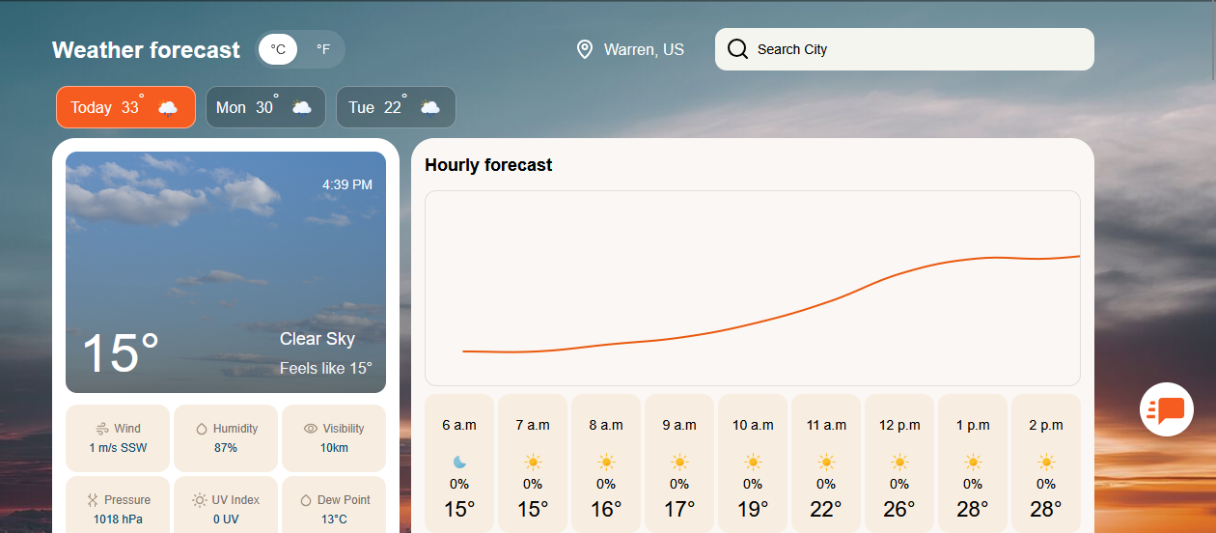I used the OpenWeather location search to enter my city zip code and acquired my city’s local weather data.
Latitude: 42.49
Longitude: -83.01

- Access Weather Data using the OpenWeather API.
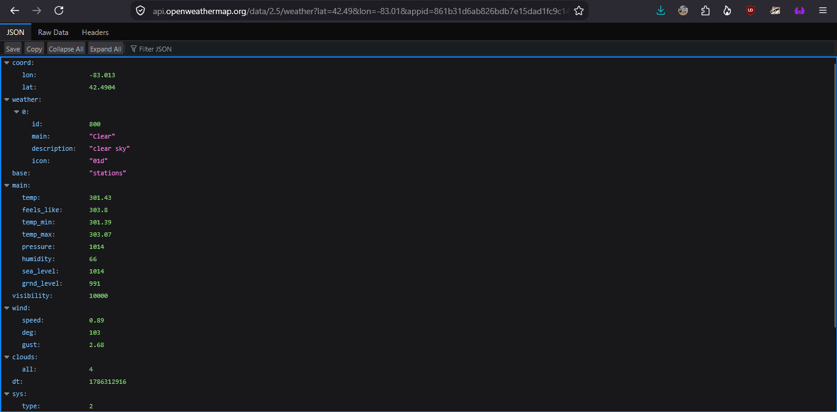 Used the OpenWeather API and input longitude and latitude values. API key from OpenWeather account was included in the request and used an HTTP request node in NODE-Red as seen in the next screenshot below.

- Process the returned weather data.
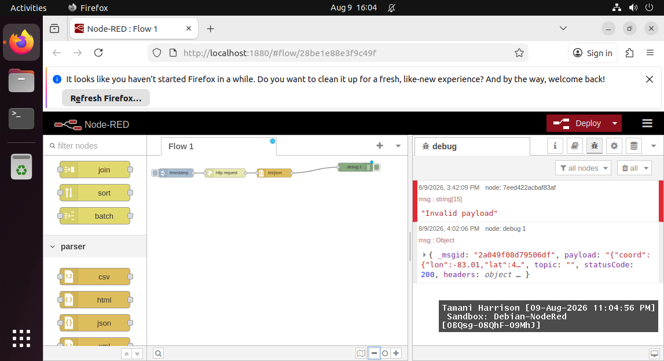
Connected a JSON Node to parse the response data.
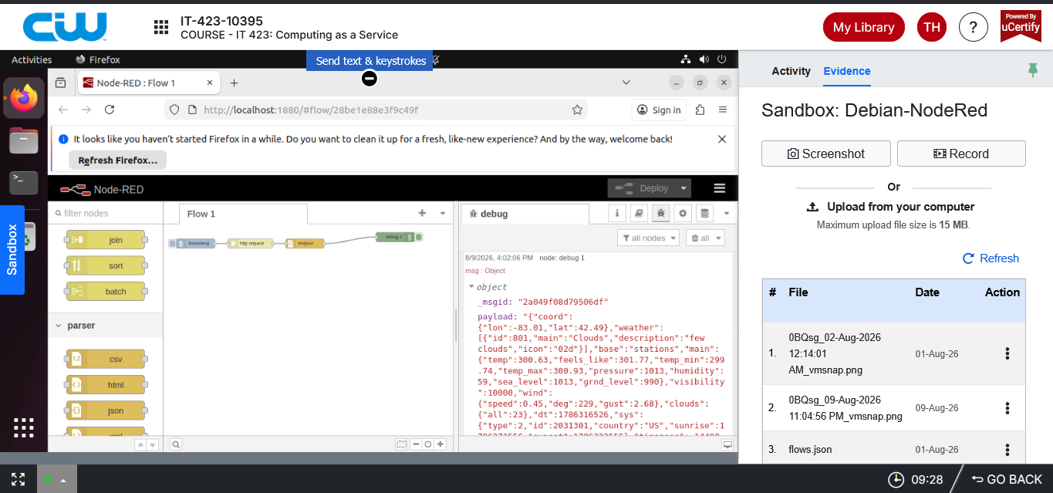
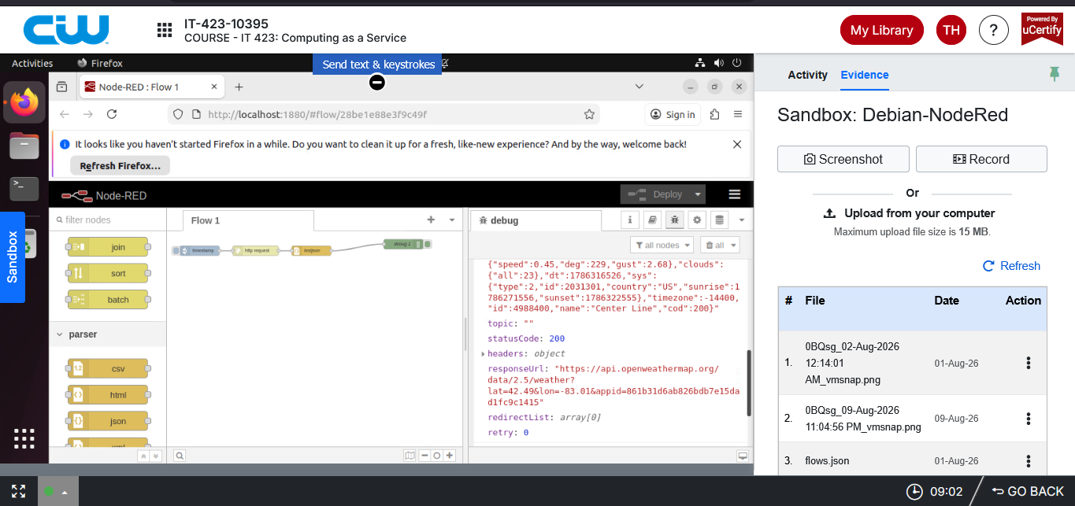
Debug node was used at end of flow to show weather data.

- Confirm your flow works.
Clicked deploy in Node Red to which the correct weather data was returned. The pictures above display the weather data in JSON format.

- Use the uCertify screenshot tool to take a screenshot of the resulting data values to demonstrate successful completion.
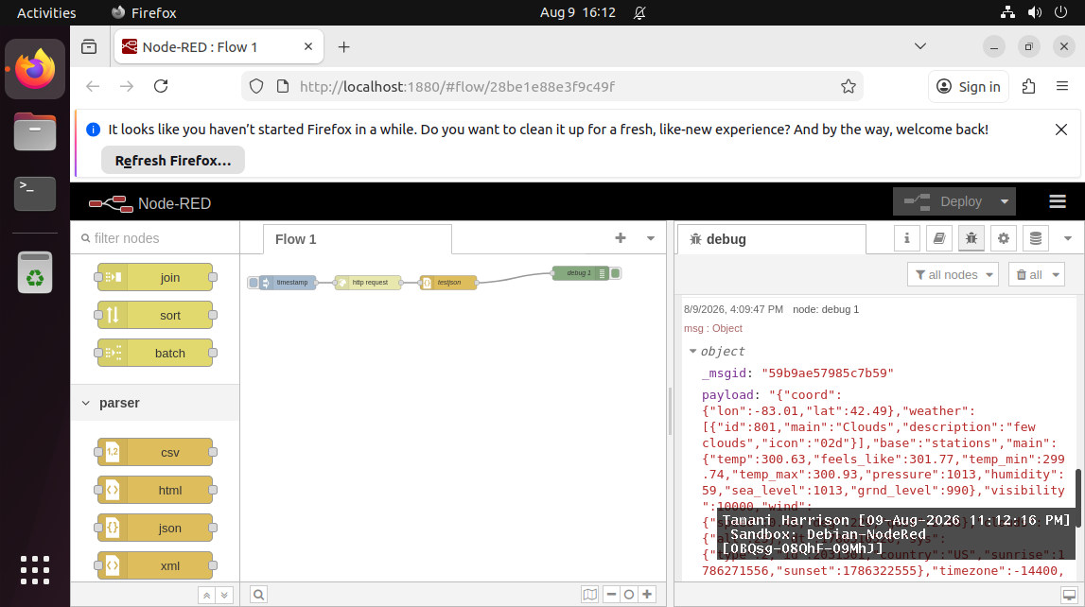
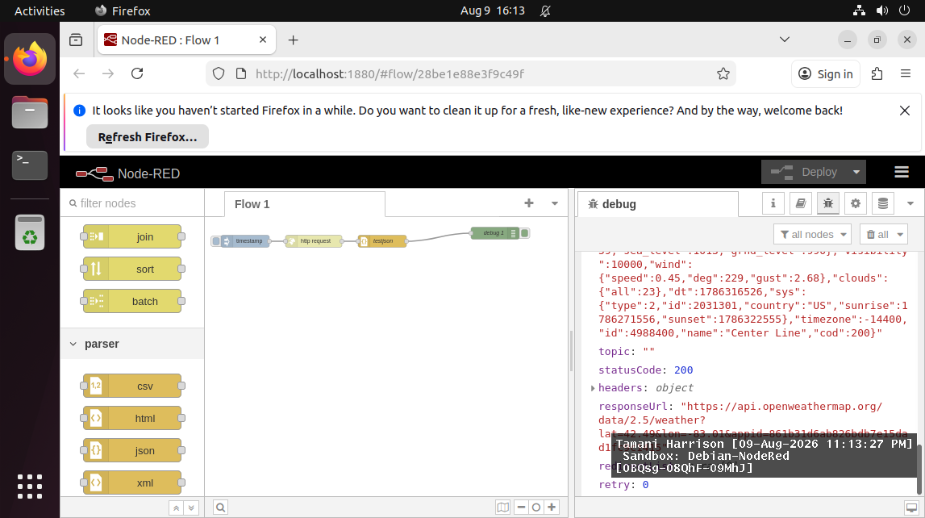

- Export your code design as a JSON file.
Attached file was submitted with assignment. Code also posted below.
[
{
"id": "28be1e88e3f9c49f",
"type": "tab",
"label": "Flow 1",
"disabled": false,
"info": "",
"env": []
},
{
"id": "e6dfeeb754971788",
"type": "inject",
"z": "28be1e88e3f9c49f",
"name": "",
"props": [
{
"p": "payload"
},
{
"p": "topic",
"vt": "str"
}
],
"repeat": "",
"crontab": "",
"once": false,
"onceDelay": 0.1,
"topic": "",
"payload": "",
"payloadType": "date",
"x": 100,
"y": 60,
"wires": [
[
"7eed422acbaf83af"
]
]
},
{
"id": "623c36fe80206e9f",
"type": "debug",
"z": "28be1e88e3f9c49f",
"name": "debug 1",
"active": true,
"tosidebar": true,
"console": false,
"tostatus": false,
"complete": "true",
"targetType": "full",
"statusVal": "",
"statusType": "auto",
"x": 720,
"y": 40,
"wires": []
},
{
"id": "7eed422acbaf83af",
"type": "http request",
"z": "28be1e88e3f9c49f",
"name": "",
"method": "GET",
"ret": "obj",
"paytoqs": "ignore",
"url": "https://api.openweathermap.org/data/2.5/weather?lat=42.49&lon=-83.01&appid=861b31d6ab826bdb7e15dad1fc9c1415",
"tls": "",
"persist": false,
"proxy": "",
"insecureHTTPParser": false,
"authType": "",
"senderr": false,
"headers": [],
"x": 270,
"y": 60,
"wires": [
[
"bee70e67d24ae874"
]
]
},
{
"id": "bee70e67d24ae874",
"type": "json",
"z": "28be1e88e3f9c49f",
"name": "testjson",
"property": "payload",
"action": "",
"pretty": false,
"x": 440,
"y": 60,
"wires": [
[
"623c36fe80206e9f"
]
]
}
]

